3rd April 2018

Successful start of TCR UK series supported by YOKOHAMA

Daniel Lloyd secured a place in history this weekend, taking victory in both of the opening rounds of the inaugural TCR UK Series at Silverstone circuit.

Driving a VW Golf GTI for the WestCoast Racing team, Lloyd, who qualified in pole position for race one, led from start to finish. Meanwhile in the reverse-grid for race 2, Lloyd powered up from the fifth row to take the chequered flag in an impressive performance.

Premium tyre manufacturer YOKOHAMA was happy with the performance of its tyres for the race weekend which saw drivers encounter changeable conditions forcing the use of both its A005 racing slick tyre and its A006 rain tyre.

“We’re pleased that the opening weekend of the TCR UK series has gone so well,” comments Mark Evans, head of motorsport at Yokohama HPT. “With new cars and varied track conditions over the weekend, it was always going to be a challenging event for the teams but as expected, our proven motorsport products allowed them to produce some fantastic race action.”

The new series saw great interest from fans at the Northamptonshire circuit as well as those unable to make it to the circuit but who followed the action online via a live stream.
Commenting on his wins at the weekend, Daniel Lloyd said, “It was an amazing start, probably one of the best first laps I’ve ever done. Sometimes you just know when you’re on it, and I’ve been like that all weekend. I’ve just had one focus right from the start, I was a hundred per cent confident and knew what I wanted to do and it paid off.”

While the UK competitors can now take a break before the next round at Knockhill in May, YOKOHAMA’s motorsport team head to the warmer climate of Morocco where their A005 and A006 tyres will be used this weekend in the opening round of the FIA World Touring Car Cup (WTCR).

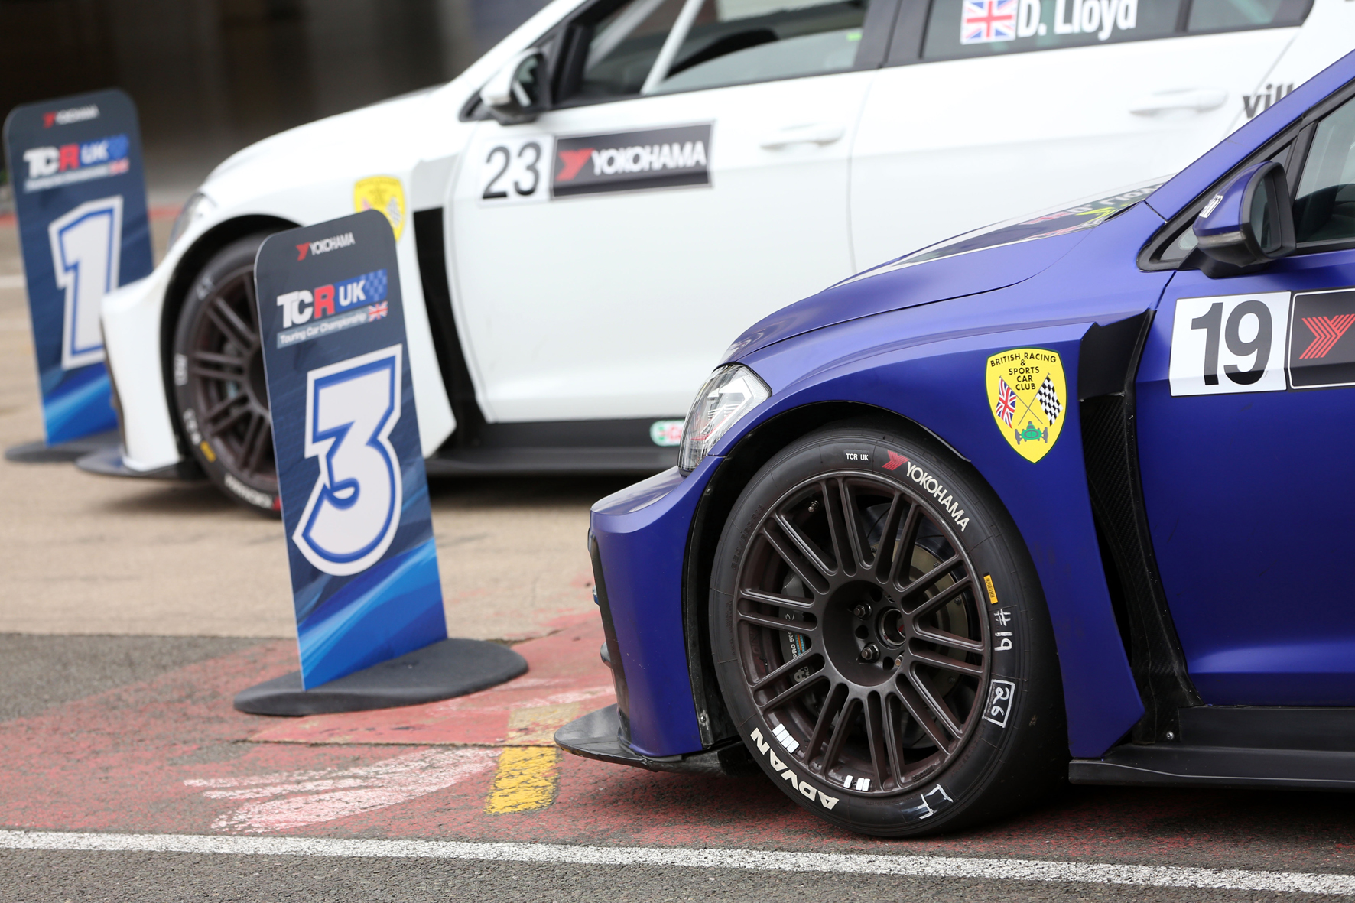
YOKOHAMA tyres

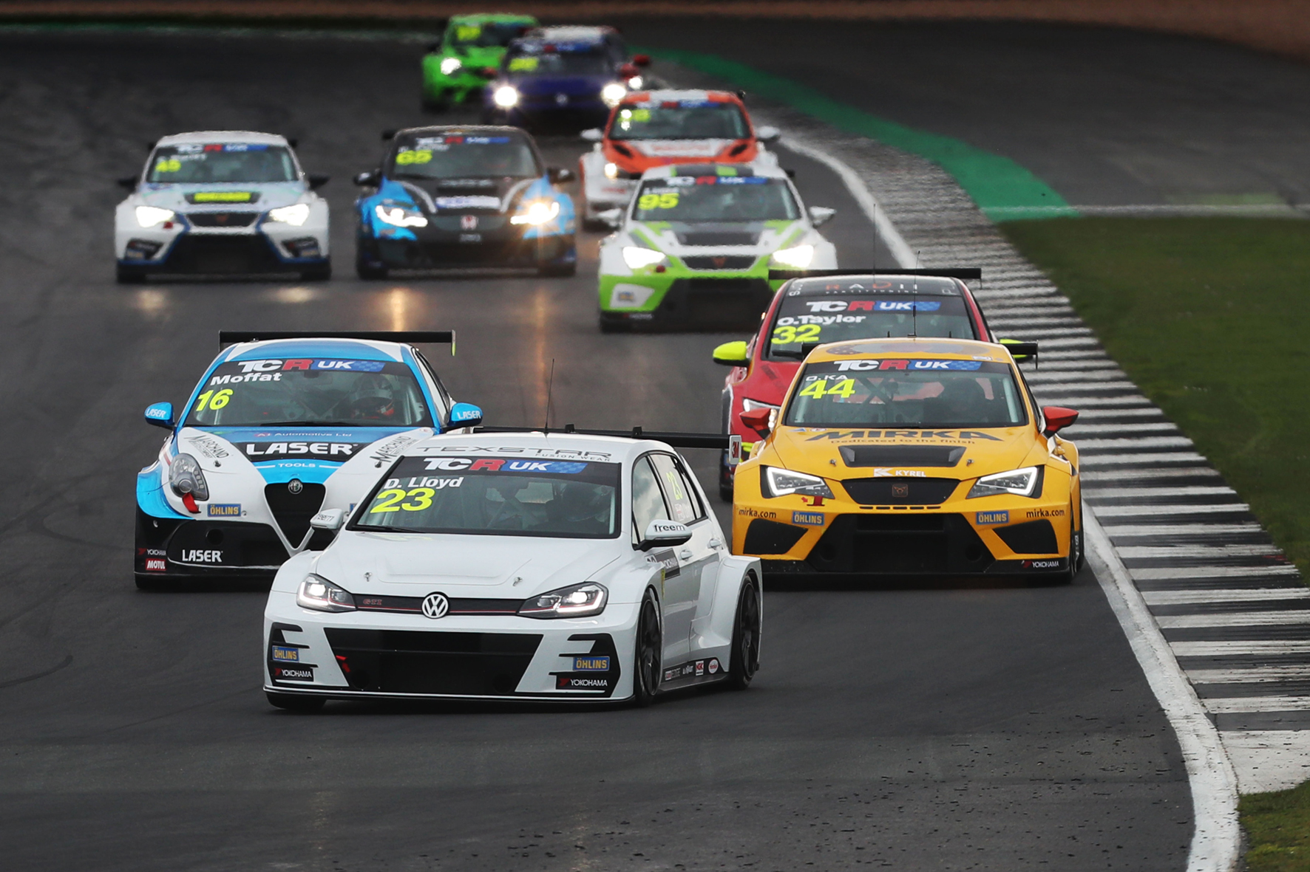
Lloyd-Race track

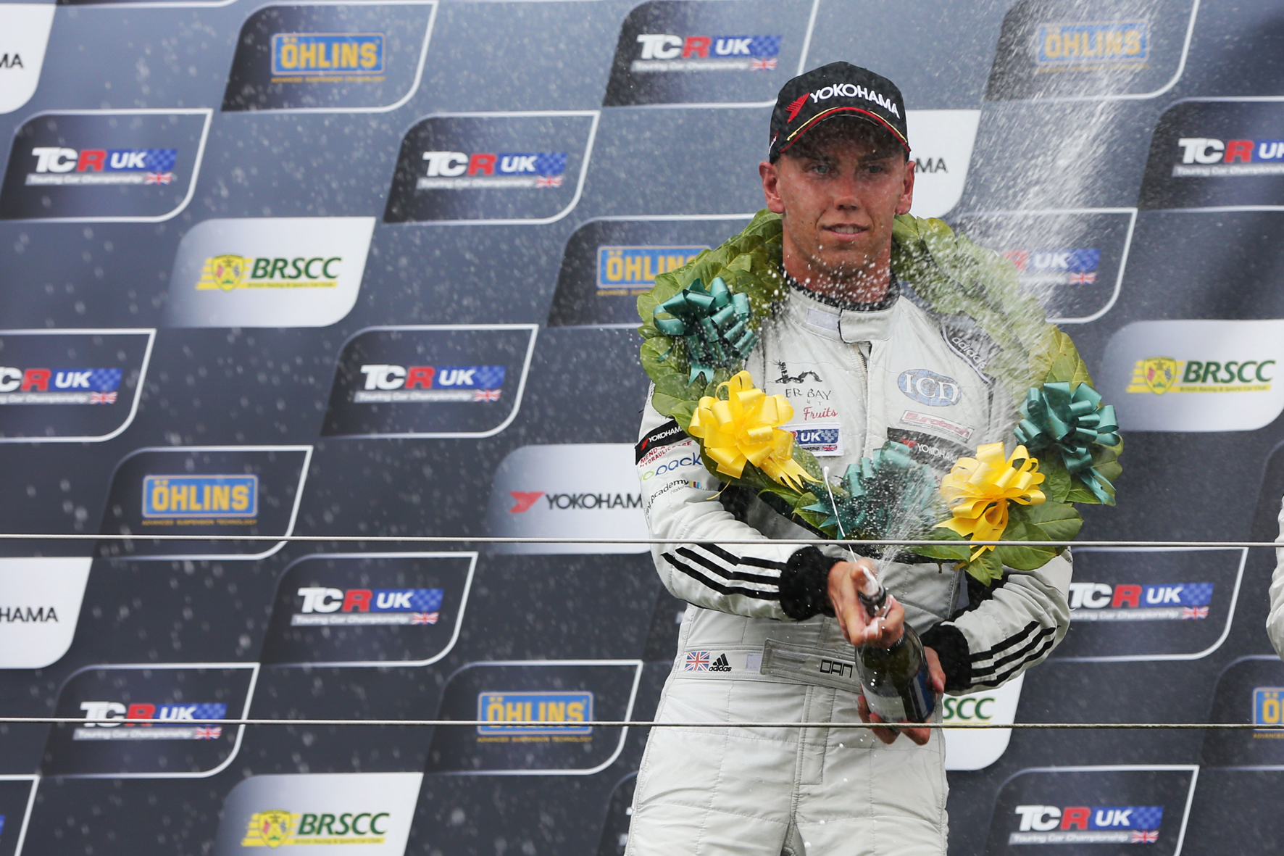
Lloyd-Podium

